# Understanding Portugal use of the biosphere’s natural resources through Ecological Footprint Accounting.

Ecological Footprint Accounting has become an increasingly used metric for natural capital and environmental accounting, and is frequently implemented in sustainability studies to provide a first macro-ecological screening of the metabolic requirements of a given population, compared with the ecosystem’s ability to provide essential life-supporting services. Just as a bank statement tracks expenditures against income, Ecological Footprint Accounting tracks human demands for key renewable resource and service flows (through a metric called Ecological Footprint) and compare them against the biosphere’s capacity to provide such resources and services (through a metric called biocapacity). Both demand and supply are expressed in hectare-equivalent units (or global hectares - gha), which represent hectares with world average biological productivity. Six main types of bioproductive areas, each providing different resources and ecosystem services, are considered as reported in Figure 1.

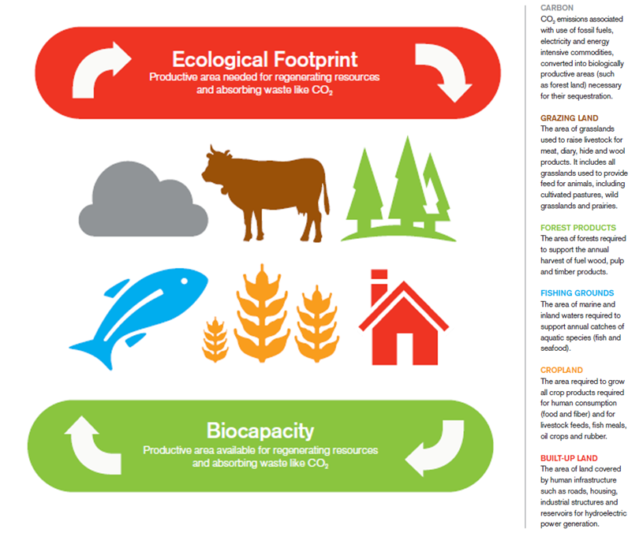

Figure 1: **HUMAN CONSUMPTION IS COMPARED TO NATURE’S PRODUCTION.** The Ecological Footprint measures people’s use of cropland, forests, grazing land and fishing grounds for providing resources and absorbing waste (carbon dioxide from fossil fuel burning). Biocapacity measures how much biologically productive area is available to regenerate these resources and services.

Ecological Footprint Accounting is applicable at scales ranging from single products to cities, from countries to the world as a whole. Each city, state or nation’s Ecological Footprint can be compared to its biocapacity thus informing on only one key aspect of sustainability *- how much Earth’s regenerative capacity human society demands, and how much is available -* not all aspects of sustainability, nor all environmental concerns. The attempt to answer this particular scientific research question is motivated by the realization – increasingly supported by a growing number of studies – that the Earth’s regenerative capacity has become the limiting factor for thriving human economies and societies.

Global Footprint Network has been calculating the Ecological Footprint and biocapacity for approximately 200 countries – in what is called the system of National Footprint Accounts – since 2003 and has recently released its latest results covering the period 1961-2013 (the most recent year for which results are available)[1]. Such results are freely available at <http://data.footprintnetwork.org/>.

When applied to Portugal (see Figure 2), results indicate that Portugal’s per person biocapacity (green line) has increased by 24% during the period 1961-2013, shifting from 1.2 to 1.5 gha per person. Such increase has been outpaced by the increase (+73%) in the country’s average per capita Ecological Footprint (red line), which went from 2.2 gha per person in 1961 to 3.9 gha per person in 2013. Over the course of the years, the country’s ecological deficit (shaded red area) has continuously increased up till the early ‘2000s and a reduction has been experienced since 2006.



Figure 2: **A WIDENING GAP BETWEEN SUPPLY AND DEMAND**

Compared to the other Mediterranean countries (see Figure 3), results indicate that, as of 2013, Portugal had the 9th highest per capita Ecological Footprint among the 24 considered Mediterranean countries, at 3.9 global hectares (gha) per capita. Meanwhile, Portugal per capita biocapacity in 2013 (1.5 gha per capita) was slightly higher than the Mediterranean regional average (1.2 gha per capita) but lower than the world average value of 1.7 gha per capita.



Figure 3: **ECOLOGICAL FOOTPRINT OF CONSUMPTION ACTIVITIES, BY LAND TYPE, OF THE 24 MEDITERRANEAN COUNTRIES, IN 2013** **/** The countries with the highest incomes currently have the highest resource demands in terms of Ecological Footprint. The carbon Footprint component contributed to the main share of the overall national Footprint value in all the countries analyzed; however, it varies the most among countries and rises with higher per capita income levels.

Such screening possibly allows understanding where and how human pressure can be reduced. Portugal ecological deficit is due to both a high level of dependency from resources and biocapacity from abroad and overuse of the local resources[2]. At a glance, food consumption (32% of the overall country’s Footprint) and mobility (18%)[3] are found to be among the daily human activities that contribute the most to Portugal’s Ecological Footprint and thus constitute hotspots for Footprint mitigation interventions.

1. For each country included in the analysis, the demand for a given resource (food, fibre, timber, etc) or ecosystem service (i.e., carbon sequestration) is first divided by the yield of such resource (or service) by land type. The values obtained are then multiplied by yield and equivalence factors and summed together to generate final national Ecological Footprint values in global hectares. Total availability of biocapacity in each nation is calculated by considering the available biologically productive land and sea areas and their capacity to produce resources and services useful for humans. Moreover, the EF measures human appropriation of biocapacity from a consumer perspective as it tracks the biocapacity appropriated because of local production activities as well as that embedded in trade flows to arrive at a final Ecological Footprint of consumption.
2. See also Galli, A., Halle, M., Grunewald, N., 2015. Physical limits to resource access and utilization and their economic implications in Mediterranean economies. *Environmental Science & Policy*, 51, 125-136.
3. See also Galli, A., Iha, K., Halle, M., El Bilali, H., Grunewald, N., Eaton, D., Capone, R., Debs, P., Bottalico, F. 2017. Mediterranean countries' food consumption and sourcing patterns: An Ecological Footprint viewpoint. *Science of the Total Environment*, 578, 383–391.